Lesson 04

Overview
This worksheet will guide you in working on the first milestone of the C372 FA Graded Assignment. In this stage, you will research market gaps, suggest an e-commerce solution, and discuss the features required, including key features like secure payments and a digital wallet.
You’ll also check which regulations apply (e.g., PCI DSS, AML/KYC, MAS guidelines) and explain how your solution meets them.
Worksheet | Notes
Section A | Your Business Idea - Product/Service Analysis
Section B | Regulatory Requirements
Section C | System Design
Section D | Functional Requirements
Section E | Submissions

Ensure that you have read through the project requirements in C372 Graded Assignment.pdf.

Section A – Your Business Idea - Product/Service Analysis
1. What market gap or customer problem will you address? Describe what is difficult, unavailable, costly or incomplete today. Record the evidence and sources that support your answer.
Customers who want to attend couples’ or creative workshops may need to contact the business directly to ask about available dates, time slots, prices and remaining places. This can be inconvenient and time consuming. Customers may also be unsure whether a workshop slot is still available. If the business sells products separately from its workshop bookings, customers may need to use different methods to make bookings and purchases.

My business will solve this problem by providing an online booking and shopping website. Customer can view workshop information, check available time slots, see prices, book workshops and pay online. They can also browse products, add items to their shopping cart and purchase them through the website.

Evidence:

Singapore’s Infocomm Media Development Authority (IMDA) describes online shop solutions as supporting product catalogues, shopping carts, secure checkout, order management and inventory management. These features support the usefulness of an online shopping system. However, I still need to validate whether my target customers experience these problems by asking potential customers about their current workshop booking experiences.

Source: IMDA, E-Commerce – Online Shop (B2C):
https://preapproval-guide.imda.gov.sg/pre-approval-guide/stage-1-vendor-self-assessment/identify-suitable-solution-category/essential-business/e-commerce-online-shop-b2c

2. What product or service will you propose?
Use the sentence pattern:
For [target audience], my [product/service] addresses [market gap] by [how it helps].
For couples, student, families and friends who want to attend workshops or buy related products, my workshop booking and online shopping website addresses the difficulty of checking workshop availability and making purchases by allowing customers to view available slots, book sessions, make online payments and purchase products through one convenient platform.

3. Who is the target audience? Identify the people who experience the need and explain what they need from the proposed service.
My target audience includes couples, students, families and groups of friends. Couples can use the service to spend quality time together through workshops. Students can join workshops to learn new skills and enjoy new experiences. Families can participate in activities together, while friends can book workshops as a group.

These customers need clear workshop descriptions, prices, dates, available time slots and information about the number of participants allowed. They also need a convenient booking process, secure online payments and booking confirmations. Customers who purchase products need product descriptions, prices, stock availability, a shopping cart and order confirmations.

Section B – Regulatory Requirements
For each potentially relevant requirement (for example PCI DSS, AML/KYC or MAS guidelines), record what it requires, why it may apply to your proposal, how your design would address it, and a reliable current source. Verify applicability; do not assume every example applies.
Requirement / source | Why it may apply | Proposed response / control | Citation
Payment Card Industry Data Security Standard (PCI DSS), from the PCI Security Standards Council. | My website allows customers to pay online using payment cards. Therefore, card payment information must be protected. PCI DSS applies to businesses and service providers that store, process or transmit carderholder data, or can affect its security. | My business will use a reputable third-party payment gateway to process card payments. The website will not store customers’ full card numbers or CVV security codes. I will confirm the applicable PCI DSS requirements with the payment provider. | https://www.pcisecuritystandards.org/standards/pci-dss/
Personal Data Protection Act(PDPA), from Singapore’s Personal Data Protection Commission(PDPC). | My website collects personal information such as customers’ names, email addresses, phone numbers and booking details. This information must be handled responsibly and protected against unauthorised access. The PDPA includes obligations relating to consent, notification, protection and retention of personal data. | My business will explain why customers’ information is collected and obtain consent where required. Only necessary information will be collected. Customer information will be protected through access controls and secure storage. Information will mot be kept longer than necessary for business or legal purposes. | https://www.pdpc.gov.sg/-/media/Files/PDPC/PDF-Files/Resource-for-Organisation/Data-Protection-Obligations-under-the-PDPA.ashx
Payment Services Act 2019, regulated by the Monetary Authority of Singapore(MAS) | My business accepts online payments for workshop bookings and product purchases. The Payment Services Act regulates certain payment services in Singapore. However, accepting payments for my own goods and services does not automatically mean that my business is providing a regulated payment service. | My business will use an appropriate external payment provider to process customer payments. I will not operate my own digital wallet or transfer money between customers. If I expand the business to provide payment services or store customers’ money, I will check the applicable MAS requirements before introducing these features. | https://www.mas.gov.sg/regulation/payments/regulations-and-guidance
Consumer Protection Act and fair trading guidance from the competition and Consumer Commission of Singapore(CCCS). | Customers need accurate information before booking workspace or purchasing products online. Misleading prices, unclear booking conditions or false availability information could cause customers to make decisions based on incorrect information. | My website will display accurate prices, workshop details, available time slots, product descriptions and stock information. The cancellation, refund and delivery or collection policies will be shown before customers confirm their purchases. The business will avoid misleading promotional claims. | https://www.cccs.gov.sg/consumer-protection/fair-trading-practices
What questions, risks or assumptions remain? Explain how your proposed controls or processes would address the applicable requirements. Distinguish sourced requirements from your own design decisions.
One assumption is that my business will sell its own workshop bookings and products and use an external payment gateway. I am not planning to provide a digital wallet or transfer money for other people. If the business model changes, I will check whether additional payment regulations apply.

There are several risks to consider. Customers might make duplicate bookings, payments might fail and unauthorised people might access customer information. To reduce these risks, the system will check slot availability before confirming a booking, update booking status based on payment results, restrict staff access to customer information and provide booking confirmations and payment receipts.

These controls are proposed design decisions. The legal requirements and their applicability must be verified against the official sources before the business launches.

Report link: summarise the applicable requirements and your proposed response in Project Overview in your own report. Include citations for researched claims.

Section C – System Design
Use-case diagram
Create a use-case diagram in draw.io or an equivalent tool. Show the system boundary, the actors that interact with it, and their goals. Use the C372 FA Graded Assignment.pdf to decide what belongs in scope; include the core selection/order/payment/result/history flow where relevant.
Attach or insert your diagram in the space below and include it in the System Design section of your own report.
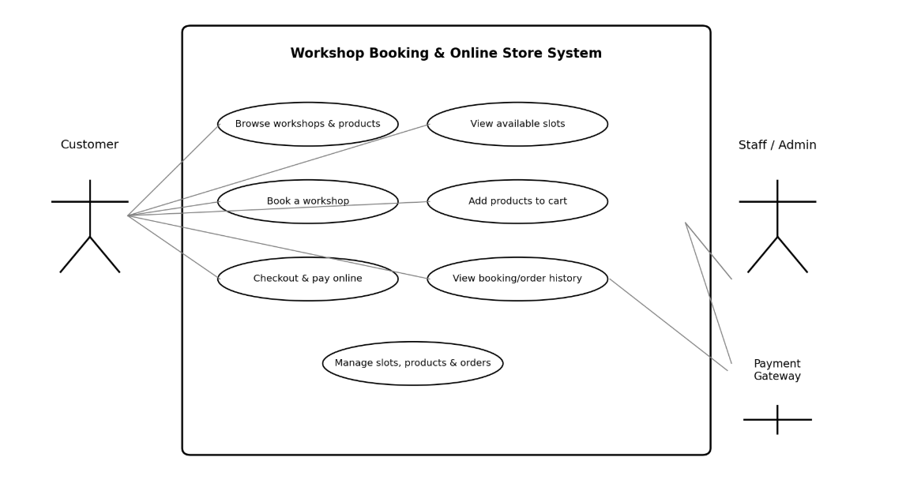

ERD and entity/field inventory
Identify the entities (tables) needed to support your use cases. List important fields and data types, mark primary and foreign keys, then draw an ERD showing the relationships and cardinality. The example entity names below are prompts only; choose what fits your proposal.

Entity/field inventory (add rows if needed):
Entity / table | Field | Data type | Key / notes
Customer | customer_id | INT | PK
Customer | name | VARCHAR(100) | Customer full name
Customer | email | VARCHAR(255) | Unique;login/contact
Customer | phone | VARCHAR(30) | Contact number
WorkshopSlot | slot_id | INT | PK
WorkshopSlot | workshop_name | VARCHAR(150) | Workshop title
WorkshopSlot | start_datetime | DATETIME | Date and start time
WorkshopSlot | capacity | INT | Maximum participants
WorkshopSlot | available_seats | INT | Must not be below zero
Booking | booking_id | INT | PK
Booking | customer_id | INT | FK to Customer
Booking | slot_id | INT | FK to Workshop Slot
Booking
Booking
Booking
Product
Product
Product
Product
Order
Order
Order
Order
OrderItem
OrderItem
OrderItem
OrderItem
OrderItem
Payment
Payment
Payment
Payment
Payment
Payment

Report link: include your use-case diagram, ERD and a short explanation of key design choices in System Design in your own report.

Section D – Functional Requirements
Starting from your use cases, write one uniquely identified functional requirement for each important system behaviour. Begin each requirement with The system shall and describe an observable result. Link each requirement to a use case and state how you could check it.
An example is shown below.
ID | Linked use case | Functional requirement | How to check it
FR-01 | Purchase a ticket | The system shall record the payment result and update the order status. | Check that the displayed status matches the recorded result.

Report link: place your numbered, testable functional requirements in the Functional Requirements section of your own report. Keep the requirement IDs consistent with your use cases.

Section E – Submissions
Deliverables
- Worksheet (Individual)
- C372 Graded Assignment Project Report–STUDENTID_STUDENTNAME.docx
(Update the relevant sections in the report from this worksheet.)
Upload your deliverables to POLITEMALL even if it is incomplete before the next session.
You can resubmit later when there are updates.

